# CONTACT INFORMATION

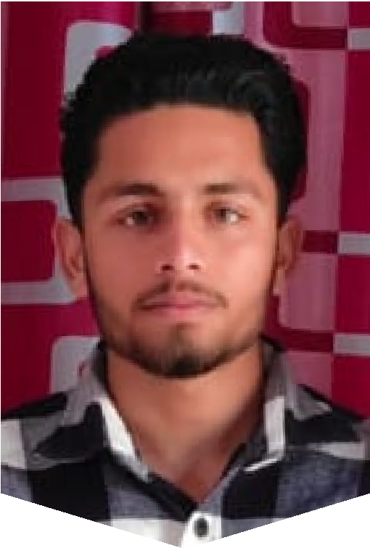

ABHISHEK SEHJAL

FULL STACK DEVELOPER

[📧shek54112@gamil.com](mailto:shek54112@gamil.com)

📞 +9178883-93203

📍 Delhi, 110085

🌐 LinkedIn:

[Linkedin.com/in/abhishek-sehjal-40a785353](https://www.linkedin.com/in/abhishek-sehjal-4a78a5353/)

🌐 GitHub:

[github.com/AbhiShekSehjal](https://github.com/AbhiShekSehjal)

🌐 Portfolio:

[my -portfolio-wiith-react-js.vercel.app/](https://portfolio-with-html-css-js-rxfg.vercel.app/)

# PROFESSIONAL SUMMARY

Hii, I am Full Stack Developer with expertise in modern web technologies, including React.js, i18n, Node.js, Express.js, MySQL, MongoDB and EJS. Passionate about building scalable applications and solving complex problems. Adept at collaborating in team environments and continuously expanding technical knowledge.

# EDUCATION

Diploma in Frontend Development ADMEC Multimedia

Institute, Rohini-Delhi 2024-2025

S.G.T.B. Khalsa College, Anandpur Sahib Bachelor of Computer Applications

2021-2024

# SKILLS

Frontend: HTML5, CSS3, JavaScript (ES6+), React.js, Tailwind CSS, Bootstrap, Figma

Backend: Node.js, Express.js, EJS

Databases: MySQL, MongoDB

Other Technologies: GitHub, VS Code, Postman

Soft Skills: Responsive Design, Problem-Solving, Team Collaboration

ABHISHEK SEHJAL

FULL STACK DEVELOPER

# LANGUAGES

 English  Hindi

 Punjabi

# HOBBIES & INTERESTS

 I was fascination for acting at the age of 18. During my college days, I participated in stage plays and theatre performances. Acting is not just about performing, it can make deep impact both the performer and the audience' lives.

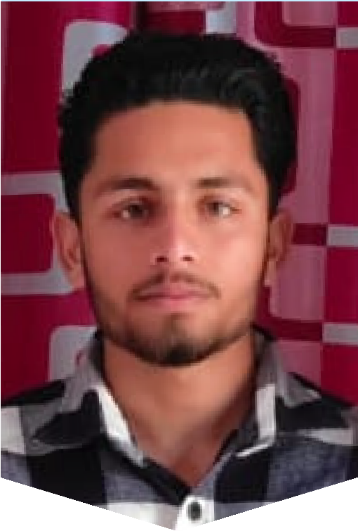

Reading has been one of my favorite hobbies. My house is filled with books on various topics outside of IT and coding. It’s a way for me to relax, learn new things, and see the world from different points of view— something that often inspires my work as a developer too.